VITyarthi
Build Your Own Project
Course Project Report
Project Title: Mini Banking Statement
Submitted By: Sayali Rajesh Khachane
Registration Number: 25BAC10008
Program: B. Tech
Course Code: CSA2001
Course Name: Electrical and Communication Engineering (AI and Cybernetics)
Faculty: Dr. Vinesh Kumar
Institution: Vellore Institute of Technology, Bhopal
Academic Year: 2025-29

Introduction
In today’s world, managing money has become an important part of daily life. Even small expenses, if not tracked properly, can create confusion about where money is being spent. Many people, especially students, do not keep a proper record of their daily transactions, which makes it difficult to manage their finances effectively.
This project, “Mini Banking System with Basic AI Analysis,” is designed to solve this problem in a simple and practical way. The aim is to create a basic banking system that allows users to perform essential operations such as depositing money, withdrawing money, checking their balance, and viewing a mini statement of recent transactions. The system is easy to use and helps users keep track of their financial activities in an organized manner.
Along with basic features, a small AI-based component is also included in the project. This feature analyses past transactions and provides simple insights into spending patterns or predicts future expenses. This shows how even a small application can become more useful by adding basic intelligence to it.
Overall, this project focuses on applying programming and AI concepts to a real-life problem. It not only helps in understanding how banking systems work but also demonstrates how technology can be used to make everyday tasks easier and more efficient.

Problem Statement
In daily life, many people do not keep track of their financial transactions in a proper and organized way. Small expenses like food, travel, or shopping are often ignored, and over time, it becomes difficult to understand where the money has been spent. This lack of tracking can lead to poor financial management and confusion about the available balance.
Although banking applications are available, they are often complex and include many advanced features that are not necessary for basic users. Students and beginners usually need a simple system that helps them perform basic operations and keep a record of their transactions without any difficulty.
The main problem addressed in this project is:
To design a simple and user-friendly system that allows users to manage their basic banking activities and track their transactions easily, while also providing basic insights into their spending habits using AI.
This project aims to provide a practical solution by creating a mini banking system that is easy to understand, efficient to use, and helpful in managing everyday financial activities.

Objectives
The main goal of this project is to create a simple and easy-to-use banking system that helps users manage their daily financial transactions without confusion. Instead of building a complex application, the focus is on making something practical and useful for basic needs. The specific objectives of this project are:
- To develop a system that allows users to deposit and withdraw money easily
- To help users check their current account balance at any time
- To maintain a record of recent transactions in the form of a mini statement
- To store transaction data safely so that it is not lost after closing the program
- To make the system simple and user-friendly, especially for beginners
- To include a basic AI feature that can give simple insights into spending habits
Functional Requirements
In this project, the Mini Banking System is designed to perform basic banking operations in a simple and efficient manner. The main functional requirements of the system are as follows:
- The system should allow the user to create an account with an initial balance.
- The system should allow the user to deposit money into their account, and the balance should be updated accordingly.
- The system should allow the user to withdraw money, only if sufficient balance is available.
- The system should display the current account balance whenever requested by the user.
- The system should maintain a record of all transactions (deposits and withdrawals).
- The system should display a mini statement showing the most recent transactions.
- The system should store all data in a file so that it is available even after the program is closed.
- The system should provide a simple menu-based interface for easy interaction.
- The system should include a basic AI feature to analyse past transactions and provide simple insights or predictions.

Non-Functional Requirements
Non-functional requirements describe how the system should perform and the qualities it should have, rather than the specific tasks it performs. The Mini Banking System, the important non-functional requirements are:
- The system should be simple and easy to use, so that even beginners can operate it without difficulty.
- The system should respond quickly to user inputs, such as deposits or withdrawals.
- The system should be reliable and correctly update the balance after every transaction.
- The system should store data safely so that no transaction information is lost.
- The system should be efficient and should not consume excessive system resources.
- The system should be easy to maintain and modify for future improvements.
- The code should be well-organized and readable for better understanding and debugging.
These requirements ensure that the system is not only functional but also user-friendly, reliable, and efficient.

Methodology
The development of the Mini Banking System followed a step-by-step approach to ensure that the system is simple, functional, and easy to understand. The focus was on building the project in a structured way by dividing it into smaller parts and implementing each part carefully.
- System Design
The system is designed as a menu-driven application where the user can choose different operations such as deposit, withdrawal, balance check, and viewing the mini statement. The overall design is kept simple so that users can interact with the system without confusion. The project is divided into the following modules:
- User Interface Module
- Banking Operations Module
- Data Storage Module
- AI Module
- Implementation Process
The project was implemented in the following steps:
- A basic menu system was created to allow user interaction
- Functions for deposit and withdrawal were implemented with proper balance updates
- A feature to display the current balance was added
- Transaction history was stored and displayed as a mini statement
- File handling was implemented using JSON to store and retrieve data
- A simple AI model was added to analyse or predict spending patterns.
- Data Handling
All user data, including balance and transaction history, is stored in a JSON file. This ensures that the data is saved even after the program is closed and can be accessed again when the system is restarted.

Tools and Technologies Used
The Mini Banking System project was developed using basic and widely used tools and technologies. The focus was on keeping the implementation simple, efficient, and easy to understand.
- Programming Language – Python
- NumPy
- Pandas
- Scikit-learn
- JSON (JavaScript Object Notation)
- Development Environment6

System Features
  - Core Features
- Account creation
- Deposit money
- Withdraw money
- Balance inquiry
- Mini statement (last few transactions)
  - Additional Features
- Persistent data storage
- Simple and user-friendly interface

Working of the System
The system starts with a menu that allows the user to select different operations. Based on user input:
- Deposit updates the balance and records the transaction
- Withdrawal deducts the amount after checking sufficient balance
- Mini statement displays recent transactions
- All data is stored in a JSON file for future use
The AI module uses past transaction data to identify spending trends or predict future expenses.

Algorithm
- Start the program
- Load existing data (balance and transactions) from the JSON file
- Display the menu with options:
  - Deposit
  - Withdraw
  - Check Balance
  - Mini Statement
  - Exit
- Take user input for the desired operation
- If the user selects Deposit:
  - Enter amount
  - Add amount to balance
  - Record transaction
  - Save updated data
- If the user selects Withdraw:
  - Enter amount
  - Check if balance is sufficient
    - If yes, deduct amount and record transaction
    - If no, display “Insufficient Balance”
  - Save updated data
- If the user selects Check Balance:
  - Display current balance
- If the user selects Mini Statement:
  - Display last few transactions
- If the user selects Exit:
  - Save data
  - Terminate the program
- End

Testing Approach
Testing is an important part of the project to ensure that the system works correctly and performs all operations as expected. In this project, a simple and practical testing approach was followed to check the functionality and reliability of the Mini Banking System.
  - Unit Testing
Each function of the system was tested individually. For example, the deposit function was tested to ensure that the balance increases correctly, and the withdrawal function was tested to verify that it does not allow transactions when the balance is insufficient.
  - Functional Testing
The complete system was tested by performing different operations through the menu. All features such as deposit, withdrawal, balance check, and mini statement were tested to ensure they work properly together.
  - Boundary Testing
Special cases were tested to check how the system behaves in edge conditions. For example:
- Withdrawing more money than the available balance
- Depositing zero or negative amounts
- Checking behaviour with no transaction history
  - Data Persistence Testing
The system was tested to ensure that data is correctly stored in the JSON file and remains available even after the program is closed and restarted.
  - Result of Testing
After performing all the tests, the system was found to be working correctly. All functions performed as expected, and the system handled both normal and edge cases effectively.

Screenshots / Output
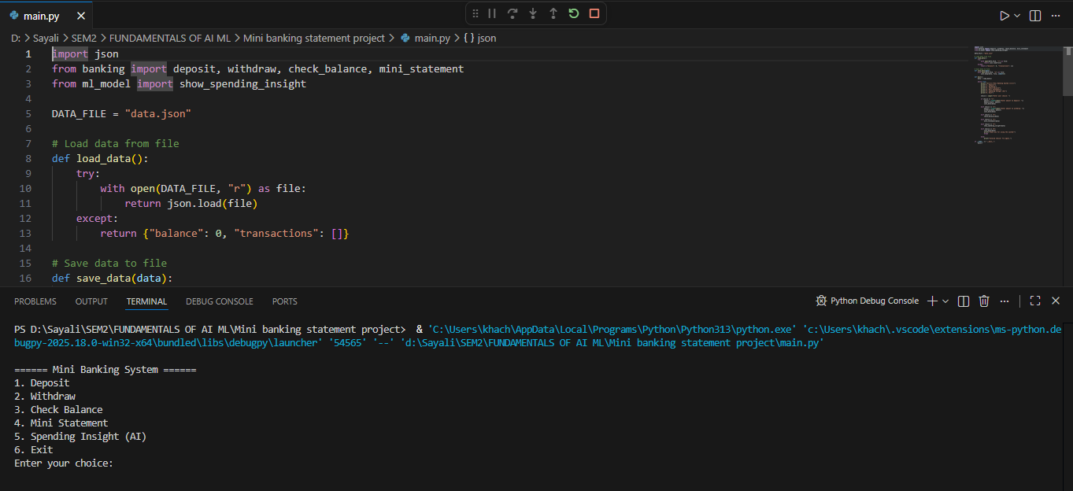
After testing the mini banking statement operation, the output shown is:
This screenshot shows the main menu of the Mini Banking System. It displays different options such as deposit, withdrawal, balance check, mini statement, and AI-based spending insight. The user selects an option from this menu to perform different banking operations. The system continues to run until the user chooses the exit option.
The user enters the amount to deposit, and the system updates the balance accordingly. The transaction is also recorded in the system. This screenshot shows the process of depositing money into the account.
Deposit added:
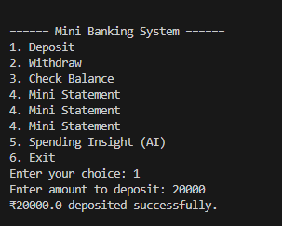

The system displays the balance after performing transactions. This screenshot shows the current account balance.
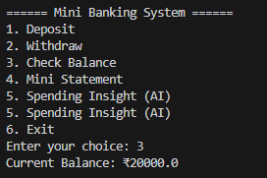
Check the balance:

The system checks whether sufficient balance is available. This screenshot shows the withdrawal process.
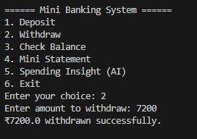
Withdrawn amount for sufficient balance:

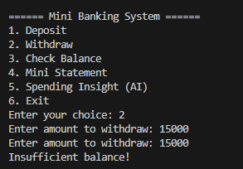
If yes, the amount is deducted; otherwise, an error message is displayed.

The system displays the updated balance after performing transactions. This screenshot shows the current account balance.
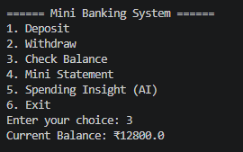
Check the balance:

The system displays the last few transactions, including deposits and withdrawals, along with the available balance. This screenshot shows the mini statement of recent transactions.
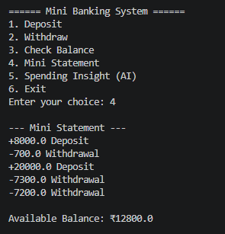
Recent transactions:

The system analyzes past transactions and displays average spending along with a simple prediction of future expenses. This screenshot shows the AI-based spending analysis feature.

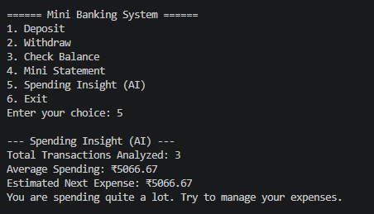
Spending Insight (AI):
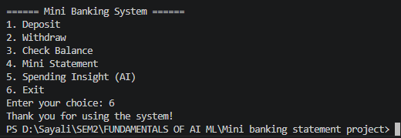
And now to exit the program:

Challenges Faced
While developing the Mini Banking System, several challenges were encountered during different stages of the project. These challenges helped in gaining a better understanding of both programming and problem-solving.
- Handling Data Storage
- Maintaining Accurate Balance
- Designing a Simple Interface
- Implementing the AI Feature
- Testing Edge Cases
- Organizing the Code
Despite these challenges, each problem was solved step by step, which improved both technical skills and understanding of real-world application development.

Learning and Key Takeaways
This project provided a valuable learning experience by combining programming concepts with basic AI techniques in a practical way. While developing the Mini Banking System, several important skills and insights were gained.
- Understanding Real-World Problem Solving
- Improvement in Programming Skills
- File Handling and Data Management
- Basic Knowledge of AI/ML Integration
- Importance of Code Structure
- Testing and Debugging Skills
- User-Cantered Design Thinking

Future Enhancements
Although the Mini Banking System successfully performs basic banking operations, there is always scope for improvement and adding more advanced features in the future.
Some possible enhancements are:
- Graphical User Interface (GUI)
- User Authentication System
- Database Integration
- Advanced AI Features
- Mobile or Web Application
- Additional Banking Features

References
The following resources were used during the development of this project:
- Python Official Documentation
- Scikit-learn Documentation
- NumPy Documentation
- Pandas Documentation
- Online tutorials and programming resources were referred to for understanding concepts related to Python, file handling, and basic AI implementation.

